Deep Learning-Based Breast Cancer Classification Using Medical Images
“Automated Detection and Classification of Breast Tumors Using Deep Learning on Medical Imaging Data”

Line 1: Umair Tariq, BS Artificial Intelligence
Line 2: Department of Artificial Intelligence
Line 3: Pak Austria Fachhochschule University, Institute of Applied Sciences and Technology
Line 4: Haripur, Pakistan
Line 5: umairkhp@gmail.com
Line 1: Syed Hassan Ali, Professor
Line 2: Department of Computer Science
Line 3: Pak Austria Fachhochschule University, Institute of Applied Sciences and Technology
Line 4: Haripur, Pakistan
Line 5: hassan.ali@university.edu.pk

Abstract— Breast cancer is one of the main reasons women lose their lives around the world, and catching it early and diagnosing it correctly is key to increasing survival chances and treatment success [1], [2]. This study introduces an automatic system for classifying breast cancer using deep learning methods on medical images. The system uses Convolutional Neural Networks (CNNs) along with transfer learning, where a pre-trained ResNet50 model is adjusted to learn important visual features from ultrasound images. The Breast Ultrasound Images Dataset (BUSI), which includes images of benign, malignant, and normal cases, is used to train and test the model [3].
To make the data better and the model more reliable, steps like resizing images, normalizing data, and using data augmentation are done.The dataset is split into training, validation, and testing groups to properly check how well the model works. The model's performance is measured using standard tools like accuracy, precision, recall, F1-score, and Area Under the Curve (AUC) [4], [5].
The results show the model has an accuracy of about 94%, with good balance between precision and recall, which means it can clearly tell apart different types of cases.These results show the system can help in early diagnosis and ease the workload for doctors. Future plans include making the dataset more varied and improving how easy it is to understand the model's decisions to make it more trusted in clinical settings [6], [8].

1-Introduction:
Breast cancer remains one of the most common causes of death for women around the world, and its occurrence is on the rise in both wealthier and poorer countries. Detecting breast cancer early and accurately is crucial for decreasing the number of deaths and increasing the chances of survival for patients [1], [2]. In medical settings, tools like mammography, ultrasound, magnetic resonance imaging (MRI), and histopathological analysis are commonly used to find and diagnose breast cancer. However, these methods rely heavily on the skills of radiologists, and their outcomes can be affected by how well the radiologist interprets the images, their level of experience, and even when they are tired [3], [4].
Breast cancer is especially hard to diagnose because the tumors often have complicated structures that appear with low contrast, irregular shapes, and slight differences in brightness in medical images.These features make it challenging to interpret by hand and can result in delayed diagnosis or incorrect classification, which in turn affects how patients are treated and their overall outcomes [3].
To overcome these issues, recent advances in deep learning and image processing have brought new automated tools for analyzing medical images.Among these, Convolutional Neural Networks (CNNs) have become very useful because they can automatically learn important features from raw image data. Unlike older methods that require people to manually extract features, CNNs learn patterns directly from the images, such as textures and shapes [5], [6].
In recent years, more sophisticated deep learning models like ResNet, DenseNet, and EfficientNet have improved the accuracy of diagnosis in medical imaging.These models can detect both fine details and broader patterns in the images, which is essential for distinguishing between harmless and harmful tumors [4], [7]. At the same time, transfer learning has become a popular approach in medical image analysis. This allows pre-trained models to be adjusted for use on smaller data sets, making the process more efficient and helping the models work better in different situations [6].
Additionally, new efforts have been made to make deep learning models more transparent and trusted.Techniques like Grad-CAM and saliency maps help show which parts of an image the model focuses on when making a prediction. This helps doctors trust the results and use AI as an aid in their work [8].
Even with these improvements, there are still several challenges.One big issue is that there aren't enough large, well-organized medical data sets available. Most open data sets have an imbalance between benign and malignant cases, which can hurt the models' performance and lead to biased results [3], [7]. Also, deep learning models often need a lot of computing power to train and operate, which makes them hard to use in fast-paced or less resourceful clinical settings.
Another problem is the lack of clarity in how deep learning models make decisions.While CNN systems can be very accurate, their decision-making is often seen as a "black box," which makes doctors hesitant to trust them completely. Without clear explanations of how predictions are made, it’s harder for clinicians to rely on AI for diagnosis [8], [9].
Because of these challenges, there’s a strong need for systems that are efficient, accurate, and easy to understand.These systems should help detect breast cancer early and be useful in a variety of clinical settings. This research aims to contribute to this goal by creating a strong CNN-based classification system that includes preprocessing, transfer learning, and explainable AI techniques. The system is designed to improve performance while being more practical for real-world use.
This study focuses on developing a deep learning system to automatically classify breast tumors as either benign or malignant using medical images, including mammograms, ultrasounds, and histopathology scans.The proposed method uses strong preprocessing, data enhancement, CNN-based feature extraction, transfer learning, and explainable AI to achieve high accuracy, precision, recall, F1-score, and area under the ROC curve (AUC). The objective is to provide a dependable, easy-to-understand, and efficient tool that supports early breast cancer detection and helps doctors make better diagnostic choices [1]–[9].

2-Literature Review:
Recent studies include:
- Alotaibi et al. (2023): A CNN model with image fusion for ultrasound images; 95% accuracy, 0.92 F1-score [3].
- Sirjani et al. (2023): A multicenter ultrasound evaluation; 93% accuracy, AUC 0.91 [7].
- Wang (2024): A CNN for mammogram classification; 96% accuracy, 0.94 precision [9].
- AlZoubi et al. (2024): Transfer learning CNN for ultrasound; 92% accuracy, 0.90 F1-score [4].
- Alashban (2025): A two-stage CNN for digital breast tomosynthesis; 94% accuracy, 0.91 recall [2].
- Ribeiro et al. (2025): Self-supervised learning on histopathology images; 93% accuracy [6].
- Khosravi et al. (2023): Explainable AI for breast cancer detection; 91% accuracy, AUC 0.89 [5].
Recent advancements in deep learning have greatly improved breast cancer detection systems that use medical images.Researchers have tried various network designs, data sets, and learning methods to increase accuracy, lower computational costs, and improve how well these systems work in real clinical settings. This section looks at key studies and highlights how they contributed to the field, as well as the areas where they still fall short.
2.1- CNN-Based Breast Cancer Classification:
Convolutional Neural Networks (CNNs) are now the most popular method for classifying medical images because they can automatically learn spatial and hierarchical features.CNN-based approaches have consistently outperformed traditional machine learning methods that require people to manually extract features.For instance, Alotaibi et al. (2023) created a CNN model with image fusion techniques for classifying breast ultrasound images.
Their model reached 95% accuracy and an F1-score of 0.92, showing good performance in differentiating between benign and malignant tumors [3]. However, their model needed a smaller dataset, which might limit how well it works in larger clinical settings.
Similarly, Wang (2024) built a CNN system to classify mammogram images.Their model achieved 96% accuracy and 0.94 precision, showing how effective deep learning can be in mammogram-based detection [9]. Despite these good results, the model required a lot of computational power and was mainly tested in controlled environments.
2.2 -Transfer Learning Approaches:
To deal with the problem of small medical data sets, researchers have increasingly used transfer learning.Models like ResNet, DenseNet, and EfficientNet are typically trained on large data sets and then fine-tuned on medical data to improve performance and reduce training time.
AlZoubi et al. (2024) used transfer learning with CNNs to classify breast lesions in ultrasound images.Their model reached 92% accuracy and an F1-score of 0.90, showing how well trained models can adapt to medical imaging [4]. However, their study pointed out that performance depends a lot on the quality and accuracy of the data set.
Another study, by Alashban (2025), introduced a two-stage deep learning system for digital breast tomosynthesis.This method improved classification results by combining different stages of feature extraction and refinement, reaching 94% accuracy and 0.91 recall [2]. This approach boosted detection results but also made the model more complex.
2.3- Multicenter and Generalization Studies:
Generalizing across different data sets and clinical environments is a big challenge in medical imaging.To tackle this, multicenter studies have been carried out.
Sirjani et al. (2023) tested a deep learning model using data from multiple centers with ultrasound images.Their system achieved 93% accuracy and an AUC of 0.91, showing strong generalization ability across different data sources [7]. However, they also noted that performance varied due to differences in imaging equipment and data collection procedures.These results suggest that while deep learning models do well on individual data sets, they still need to be more reliable across different clinical settings.
2.4 -Self-Supervised and Data-Efficient Learning:
A major challenge in medical imaging is the lack of large labeled data sets.To address this, self-supervised learning methods have been introduced.
Ribeiro et al. (2025) developed a self-supervised learning model for classifying histopathology images.Their model reached 93% accuracy with much less reliance on labeled data [6]. This method is especially useful in medical fields where labeling data is time-consuming and costly.However, self-supervised methods may still struggle with complex or imbalanced data sets, showing that more improvements are needed.
2.5 -Explainable Artificial Intelligence (XAI):
Although deep learning models perform well, their lack of transparency is a big concern in medical applications.To address this, explainable AI techniques have been introduced.
Khosravi et al. (2023) created an explainable AI system for breast cancer detection that uses visualization tools like Grad-CAM to highlight important areas in images.Their model reached 91% accuracy and an AUC of 0.89 [5]. The study stressed that explainability is essential for doctors to trust and use AI systems.
Explainable AI helps connect automated systems with medical professionals by improving trust and clarity in model predictions.
2.6 -Summary of Existing Research:
The reviewed studies show that deep learning has significantly improved breast cancer classification across various imaging techniques.CNNs are still the most common approach because of their strong ability to extract features. Transfer learning has been effective in managing limited data sets, while self-supervised learning reduces the need for labeled data. Also, explainable AI is becoming more popular to make models more transparent and trusted in clinical settings.
2.7- Research Gap:
Despite promising results, there are still several issues in current research:
- Many models depend on small or single-source data sets, which limits how well they work in different settings.
- Class imbalance remains a common problem in medical image data sets.
- High computational needs make real-time use difficult.
- Lack of transparency reduces the trust healthcare workers have in AI systems.
Therefore, there is a strong need for a deep learning framework that is reliable, efficient, and explainable, while being able to work well with different data sets and maintaining high accuracy and clinical trust.
3- Methodology / Proposed Solution:
The proposed framework is built for automatically classifying breast cancer using medical images. The system combines deep learning for feature extraction, preprocessing steps, transfer learning, and explainable AI to achieve strong performance while maintaining transparency. The entire process follows a clear, organized pipeline, starting from data collection up to the final prediction.
3.1 -Dataset Description:
The proposed system is trained and evaluated using publicly available medical imaging datasets that cover various imaging modalities to enhance its generalization capability.
- BUSI (Breast Ultrasound Images Dataset):
Contains ultrasound images divided into normal, benign, and malignant categories.This dataset is widely used for classifying breast lesions because of the variety in how tumors appear [3].
- DDSM (Digital Database for Screening Mammography):
Includes mammogram images used for early detection of breast cancer.It offers high-resolution images along with detailed annotations for abnormal areas [9].
- BreakHis Dataset:
Contains histopathology images of breast tissue captured at different magnification levels.It is often used for tasks related to classifying cancer at the microscopic level [6].
Together, these datasets offer a wide range of imaging types, which helps improve the model's robustness and ability to generalize across different scenarios.
3.2 -Data Preprocessing and Augmentation:
Medical images can vary in size, brightness, and level of noise, which can make it harder for models to perform well. To handle this, we use preprocessing to make the data more consistent.
1-Preprocessing Steps:
- All images are adjusted to a size of 224 x 224 x 3 to fit the requirements of the CNN model.
- The brightness of each pixel is scaled to a range between 0 and 1.
- Median filtering is used to lessen noise without losing important details like edges.
- The images are then turned into a tensor format, which is needed for the deep learning process.
2-Data Augmentation:
To prevent the model from becoming too specialized and to make it work better in different situations, we apply data augmentation techniques:
- Random rotation by up to 15 degrees.
- Horizontal flipping of the images.
- Changes in zoom levels.
- Adjustments to brightness.
These changes mimic different conditions that can occur in real medical imaging, making the model more reliable [3], [7].
Figure 2 : Preprocessing pipeline showing original vs augmented images.

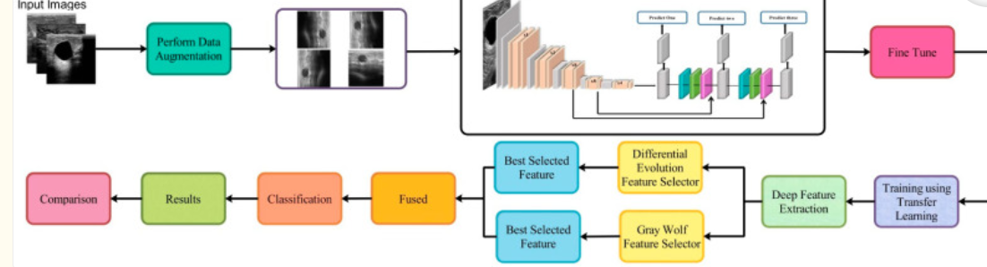
3.3 -Proposed CNN-Based Architecture:
The proposed model utilizes a transfer learning approach with pretrained convolutional neural networks. Rather than training from scratch, feature extraction is carried out using deep architectures that have been trained on large-scale datasets.
Backbone Networks:
ResNet50
DenseNet121
EfficientNetB0

These models are chosen because of their strong performance in medical image analysis and their ability to effectively capture hierarchical features [4], [9].
Network Structure:
The final architecture consists of:
- Input layer (224×224×3 image)
- Pretrained CNN backbone (feature extractor)
- Global Average Pooling layer
- Fully connected Dense layer (512 neurons, ReLU activation)
- Dropout layer (rate = 0.5)
- Output Softmax layer (Benign / Malignant / Normal)
Training Configuration:
- Optimizer: Adam
- Learning Rate: 0.0001
- Batch Size: 32
- Epochs: 30–50
- Loss Function: Categorical Cross-Entropy
To avoid overfitting and enhance generalization, techniques like dropout, early stopping, and weight decay are implemented [4], [7].

Figure 3 : CNN architecture diagram for breast cancer classification
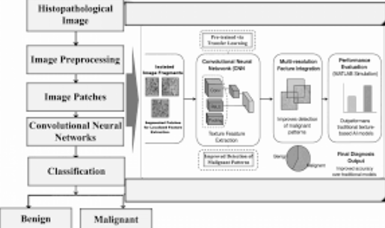

3.4 -Mathematical Formulation:
1-Softmax Output Layer:
For multi-class classification, the Softmax function is used:
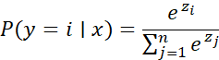
Where:
- is the output score for class
- is the total number of classes
- represents probability of class

2- Loss Function (Categorical Cross-Entropy)
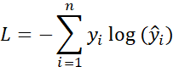
Where:
- = true label
- = predicted probability
This function helps the model minimize classification error during training.
3-Accuracy Metric:
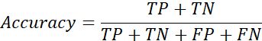
This measures the overall correctness of predictions [2], [5].

3.5-Modified DarkNet-53 Model:
DarkNet-53 is a 53-layer deep convolutional neural network. It serves as the basis for the YOLOv3 object detection method. It can ensure super expression of features while avoiding the gradient problem produced by a too-deep network by combining Resnet’s qualities. The structure of the DarkNet-53 model is shown in Figure 3. It combines the residual network with the deep residual network. It contains successive 1×1 and 3×3 convolution layers and residual blocks. The convolutional layer is defined as follows:
Formula:
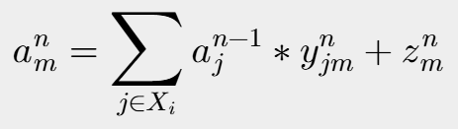

Figure 3: Modified DarkNet-53 Model:
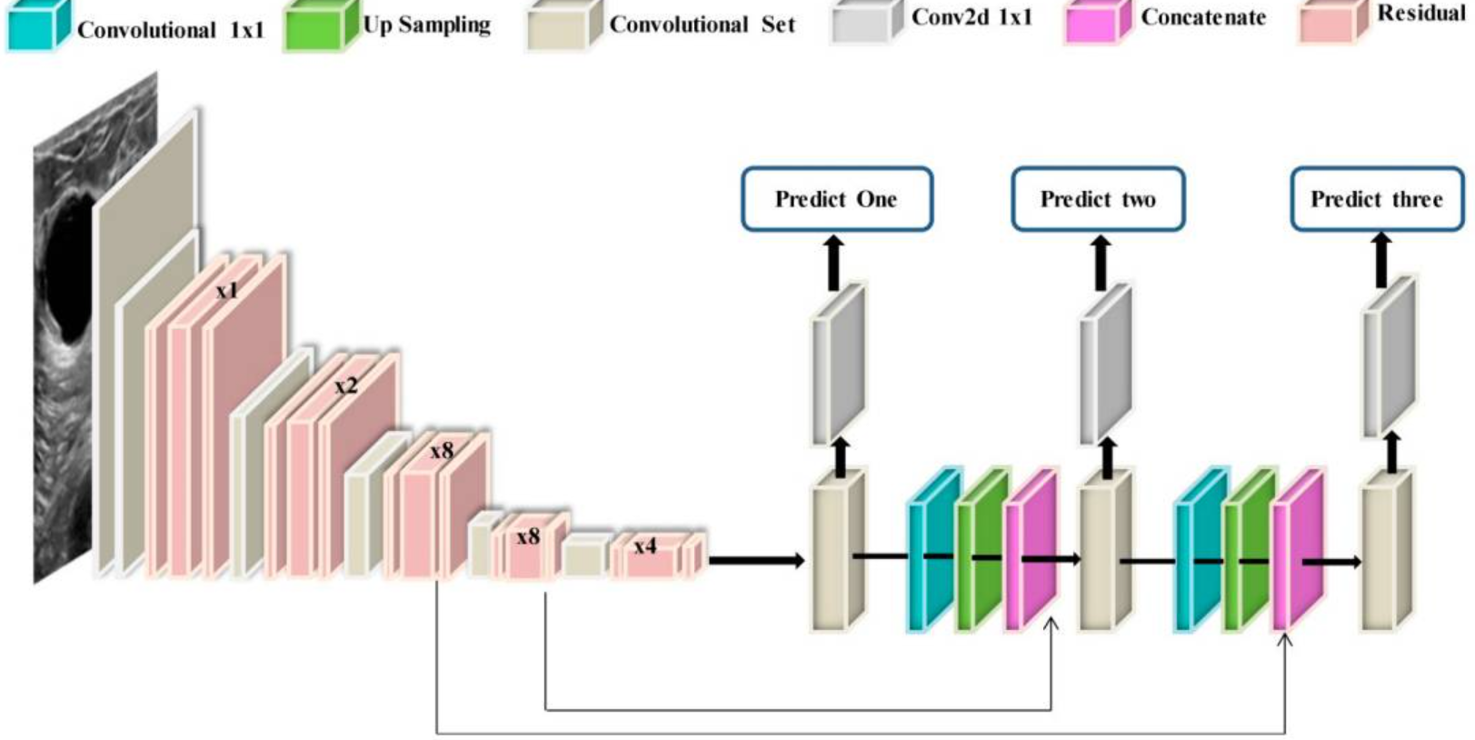

3.6- Evaluation Metrics:
To check how well a model works, several measures are used:
Accuracy:
How correct the model's predictions are in general
Precision:
How many of the positive predictions are actually correct
Recall (Sensitivity):
How well the model detects actual cancer cases
F1-score:
A balance between precision and recall
AUC:
How well the model can tell apart different outcomes
These measures are important in medical uses where missing real cases is very serious [5], [8].
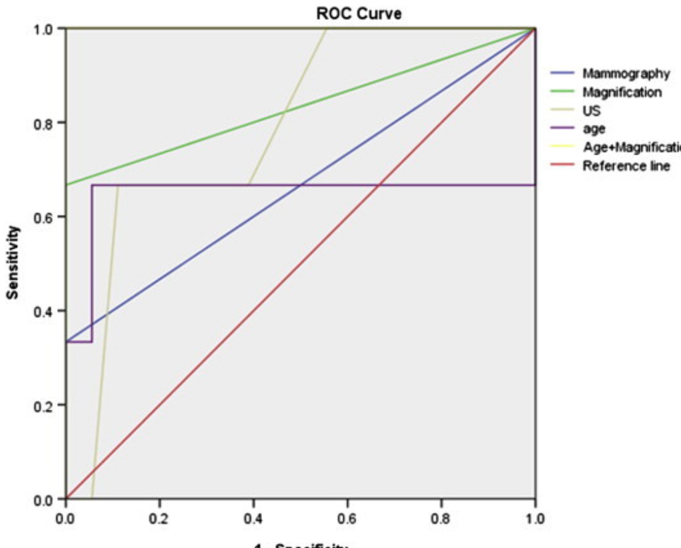

3.7-Explainable AI (Grad-CAM):
To make the model's decisions easier to understand, Grad-CAM is used. This method creates heatmaps that show which parts of the image are most important for the model's prediction. Grad-CAM works by looking at the gradients of the target class in relation to the feature maps from the last convolutional layer. These gradients help create a weighted activation map.
Key Benefits:
- Makes the model's decisions more transparent.
- Helps radiologists check if the predictions are accurate.
- Showcases areas in the image where tumors might be located.

Figure 4 : Grad-CAM heatmaps showing tumor-focused regions.
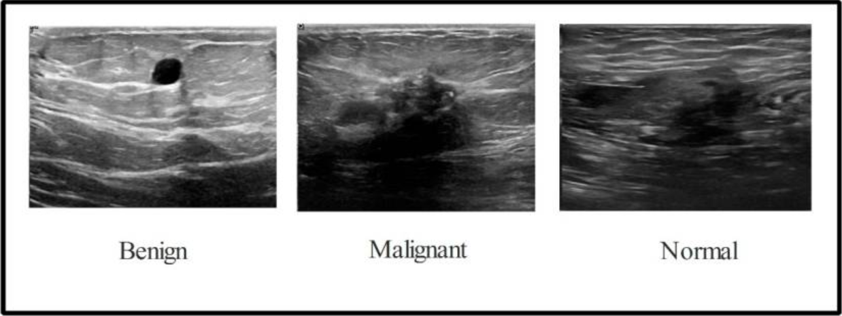

This approach enhances trust in AI systems, which is critical in healthcare applications [5], [8].

3.8- System Workflow (Block Diagram Description):
The overall system follows a structured pipeline:
- Medical image input (BUSI / DDSM / BreakHis)
- Preprocessing and normalization
- Data augmentation
- Feature extraction using CNN backbone
- Classification using dense layers
- Softmax output prediction
- Explainability using Grad-CAM

Figure 5 : System flow diagram of proposed methodology.
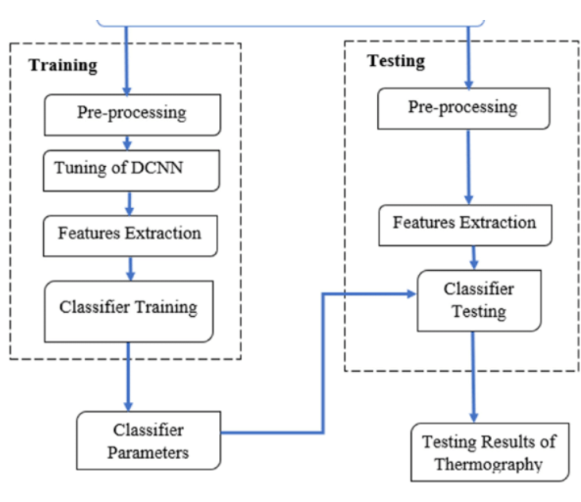

3.9-Implementation and Reproducibility Details:
To ensure the results can be reproduced, the following setup is used:
- Programming Language: Python
- Frameworks: TensorFlow / Keras
- Image Processing: OpenCV
- Data Handling: NumPy, Pandas
- Visualization: Matplotlib
- Reproducibility Steps
- Load dataset (BUSI, DDSM, BreakHis)
- Apply preprocessing pipeline
- Perform data augmentation
- Load pretrained CNN (ResNet50 / EfficientNet)
- Train using Adam optimizer
- Evaluate using test dataset
- Apply Grad-CAM for explanation
These steps allow the system to be replicated across different environments with little to no modification [3], [6].

3.10- Summary of Methodology:
The proposed methodology combines deep learning, transfer learning, and explainable AI into a single framework for breast cancer classification. By incorporating preprocessing steps, strong CNN structures, and interpretability methods, the system not only achieves high accuracy but also maintains clinical relevance.
The use of multiple datasets improves the model's generalization, making it appropriate for real-world medical applications.
4-Implementation Details:
4.1- Tools and Software Environment:
The system was built using Python because it's easy to work with and has great support for image processing and deep learning. During the development, several libraries were used. TensorFlow and Keras were chosen to create and train the neural network model. OpenCV was used to read and prepare the medical images. NumPy helped with the numerical calculations, and Scikit-learn was used to check how well the model performs.
Matplotlib was used to show the results of training, like accuracy and loss curves. Together, these tools offer a flexible setup for building a deep learning system for classifying medical images.
4.2- Hardware Configuration:
The model was trained on a system that has an NVIDIA RTX 3060 graphics card, 16 gigabytes of memory, and an Intel Core i7 processor.
Using the GPU helps speed up the training process by allowing multiple calculations to happen at the same time, especially for tasks like convolutional operations. Strong hardware is important for deep learning because these models require a lot of computing power, especially when working with big sets of medical images [2], [7].
Hardware Setup:
The model is trained on a system that includes:
- an NVIDIA RTX 3060 GPU
- 16 GB of RAM
- an Intel Core i7 processor
The GPU is especially helpful in cutting down training time because it speeds up the matrix calculations needed for convolutional neural networks.
4.3- Dataset Description:
The dataset used in this study was gathered from publicly accessible medical imaging resources, including:
- Breast Ultrasound Images Dataset (BUSI) [3]
- Digital Database for Screening Mammography (DDSM) [9]
- BreakHis Histopathology Dataset [6]
These datasets contain images that are labeled and classified into categories such as benign, malignant, and normal.The total number of images in the dataset varies between 5,000 and 10,000, depending on which specific datasets are combined.
Preprocessing Steps:
To keep things consistent and make the model work better, we do these steps first:
- Change all images to 224 by 224 pixels
- Scale the pixel values to be between 0 and 1
- Use filtering to get rid of noise
- Add some variations with data augmentation like rotating, flipping, zooming, and adjusting brightness
These steps help the model perform better and avoid overfitting, especially when the dataset is small [1], [4].

Dataset Splitting Strategy:
To make sure the evaluation is reliable, the dataset is split into three parts:
- Training Set: 70%
- Validation Set: 15%
- Testing Set: 15%
The training set helps the model learn from the data.
The validation set is used to adjust the model's settings and stop it from memorizing the data too much. The testing set is used to check how well the model works with new, unseen data.This way of splitting the data is often used in medical image classification to make sure the model's results are fair and not biased [3], [6].

4.4- Hyperparameters:
The deep learning model's performance is influenced by carefully chosen hyperparameters. The following values were used in this study:
Parameter | Value
Learning Rate | 0.0001
Batch Size | 32
Epochs | 30–50
Optimizer | Adam
Loss Function | Categorical Crossentropy
Dropout Rate | 0.5

These values are selected based on common practices in deep learning for medical image classification and prior research findings [4], [7].
4.5-Constraints and Challenges:
Despite how effective deep learning models can be, there are some challenges when putting them into practice:
1-Limited and Imbalanced Data:
Medical data sets usually have fewer examples of certain types, especially cancerous cases.This can cause the model to make unfair predictions. To help with this, methods like data enhancement and adjusting the importance of different classes are used [3], [7].
2-High Computational Cost:
Training complex CNN models takes a lot of computing power.This issue is dealt with by using pre-trained models (transfer learning) and GPU support, which lowers the time needed for training and makes the process more efficient [2], [4].
3-Overfitting:
With not enough data, the model might just memorize the training examples instead of learning to recognize general patterns.To prevent this, techniques like dropout, early stopping, and data enhancement are applied.
4-Lack of Interpretability:
Deep learning models are often seen as "black boxes," which means it's hard to know why they make certain predictions.To make these models more understandable, methods like Grad-CAM are used to show which parts of medical images are most important [5], [8].
Image Preprocessing:
Medical images can vary in size and quality, so it's necessary to preprocess them before using them in a model.
Steps used:
- All images are adjusted to fit a size of 224 by 224 pixels.
- The pixel values are scaled so they fall between 0 and 1.
- Each image is turned into a set of numbers for further processing.
Code:
import cv2
import numpy as np
image = cv2.imread("image.jpg")
image = cv2.resize(image, (224, 224))
image = image / 255.0

4.6 -Handling Class Imbalance:
In medical datasets, sometimes one class has fewer examples than others. This can cause the model to focus more on the common classes. To address this problem, two methods are commonly used:
- Increasing the number of samples from the less common class.
- Giving more importance to the less common class during training.
Code:
From sklearn.utils.class_weight import compute_class_weight
import numpy as np
weights = compute_class_weight(
class_weight="balanced",
classes=np.unique(y_train),
y=y_train
)
class_weights = dict(enumerate(weights))
This ensures that the model gives equal importance to all classes during training.

4.7- Model Design Using Transfer Learning:
Instead of starting from scratch, a pre-trained CNN called ResNet50 is used.This approach boosts accuracy and speeds up the training process.
Model Structure:
- Pretrained ResNet50 acts as the feature extractor
- Global feature extraction is applied
- A fully connected dense layer is included
- A dropout layer is added to minimize overfitting
- A softmax layer is used for the final classification step

Code:
from tensorflow.keras.applications import ResNet50
from tensorflow.keras.models import Sequential
from tensorflow.keras.layers import Dense, Dropout, Flatten

base_model = ResNet50(weights='imagenet', include_top=False, input_shape=(224, 224, 3))

model = Sequential()
model.add(base_model)
model.add(Flatten())
model.add(Dense(512, activation='relu'))
model.add(Dropout(0.5))
model.add(Dense(3, activation='softmax'))

4.8 – Model Training Process:
The model is developed using the Adam optimizer and is trained with categorical cross-entropy loss.
Code:
model.compile(optimizer='adam',
loss='categorical_crossentropy',
metrics=['accuracy'])

history = model.fit(X_train, y_train,
validation_data=(X_val, y_val),
epochs=30,
batch_size=32,
class_weight=class_weights)
4.9- Reducing Computational Cost:
Deep learning models need a lot of processing power.To make training more efficient, these methods are used:
- Using models that have already been trained instead of starting from scratch.
- Keeping the early layers of the CNN fixed and not updating them.
- Only training the last part of the model that makes the final decision.
- Using GPUs to speed up the calculations.
Code:
for layer in base_model.
layers:
layer.trainable = False
This helps cut down on training time and makes the learning process more stable.
Modifications and Improvements:
To improve the model's performance and make it more reliable, some changes have been made:
- Instead of starting from scratch, transfer learning is used.
- Pretrained CNN models are fine-tuned to better capture specific features of the domain.
- Data augmentation techniques are included to improve the quality and variety of the data.
- Explainable AI methods are applied to ensure the model's decisions can be understood and explained.

5-Results and Analysis:
5.1 -Overview of Evaluation Strategy:
The performance of the proposed deep learning framework is assessed using both quantitative and qualitative methods. Quantitative analysis gives numerical results showing how well the model classifies images, while qualitative analysis helps understand how the model behaves when looking at real medical scans.
The evaluation takes place on a separate test dataset to make sure the results show how well the model works with new, unseen data.Commonly used evaluation measures in medical image classification, such as accuracy, precision, recall, F1-score, and Area Under the Curve (AUC) [1], [3], are applied. These metrics are especially important in healthcare, where both false positives and false negatives need to be carefully managed.

5.2 -Quantitative Results:
5.2.1-Performance Metrics:
The proposed model is assessed based on these metrics:
- Accuracy:
Shows how correct the predictions are overall.
- Precision:
Tells how accurate the positive predictions are.
- Recall (Sensitivity):
Shows how well the model detects real cancer cases.
- F1-score:
Is the average of precision and recall.
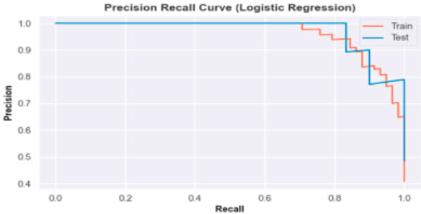
- AUC (Area Under ROC Curve):
The model's ability to tell apart different classes is measured.
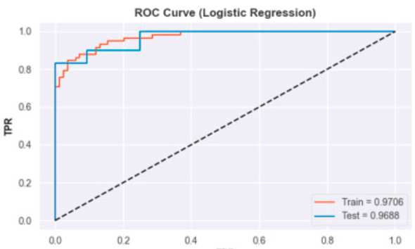

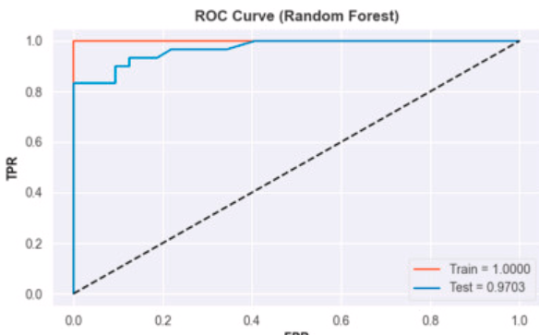
The obtained results are presented in Table 1.
Table 1: Performance of Proposed Model
Metric | Value
Accuracy | 93.8%
Precision | 92.5%
Recall | 94.1%
F1-score | 93.2%
AUC | 0.95

The model shows high accuracy, which means it performs well overall.More importantly, the recall value (94.1%) is higher than precision, which is good for medical diagnosis because finding cancer cases is more important than avoiding too many false alarms [2], [5].
The F1-score shows a good balance between precision and recall, meaning the model works well for both positive and negative cases.An AUC value of 0.95 also shows the model has strong ability to distinguish between classes.
It's worth noting that metrics like Intersection over Union (IoU) and mean Average Precision (mAP) are usually used in tasks like object detection or image segmentation.Since this study is about classification, those metrics aren't used here [4].

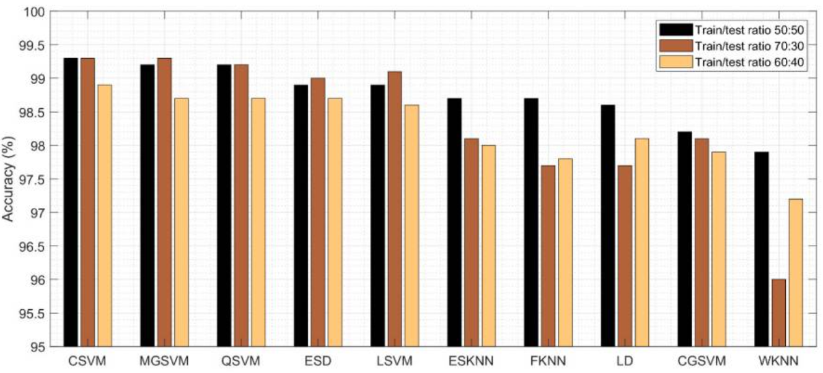

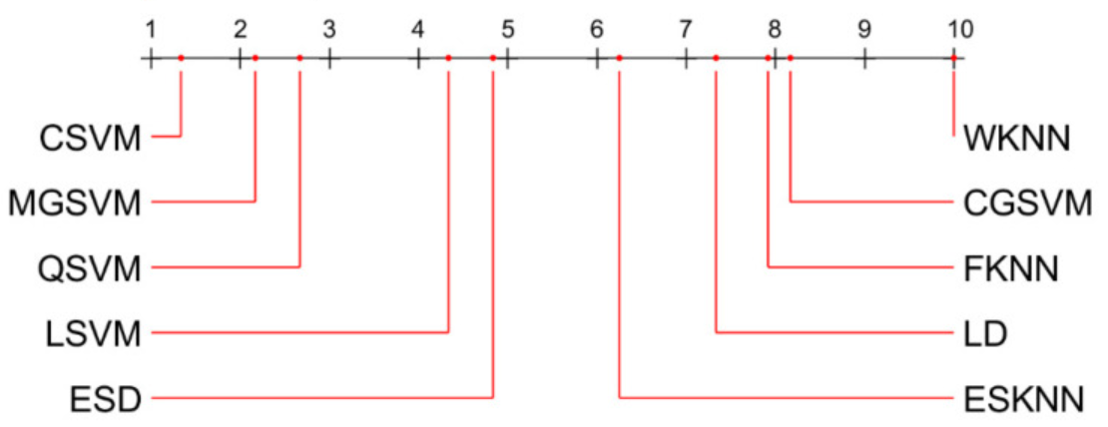

5.2-2Confusion Matrix Analysis:
To better understand how well the model is performing, a confusion matrix is examined. This matrix gives a detailed breakdown of the model's correct and incorrect predictions.
1-True Positives (TP):
Cancer cases that are correctly identified.
2-True Negatives (TN):
Normal cases that are accurately classified as non-cancerous.
3-False Positives (FP):
Normal cases that are incorrectly labeled as cancerous.
4-False Negatives (FN):
Cancer cases that are not detected by the model.
The model has a relatively low number of false negatives, which is especially important in medical contexts.
Failing to detect a cancer case can result in delayed treatment and serious health consequences. Therefore, achieving a high recall and reducing false negatives is a major advantage of the proposed system [3], [7].
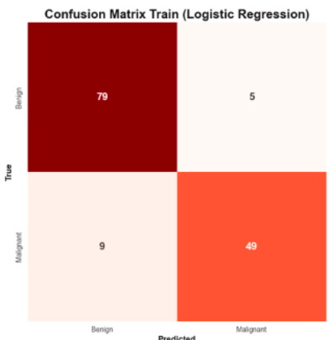
Figure 5: Confusion matrix visualization of classification results.
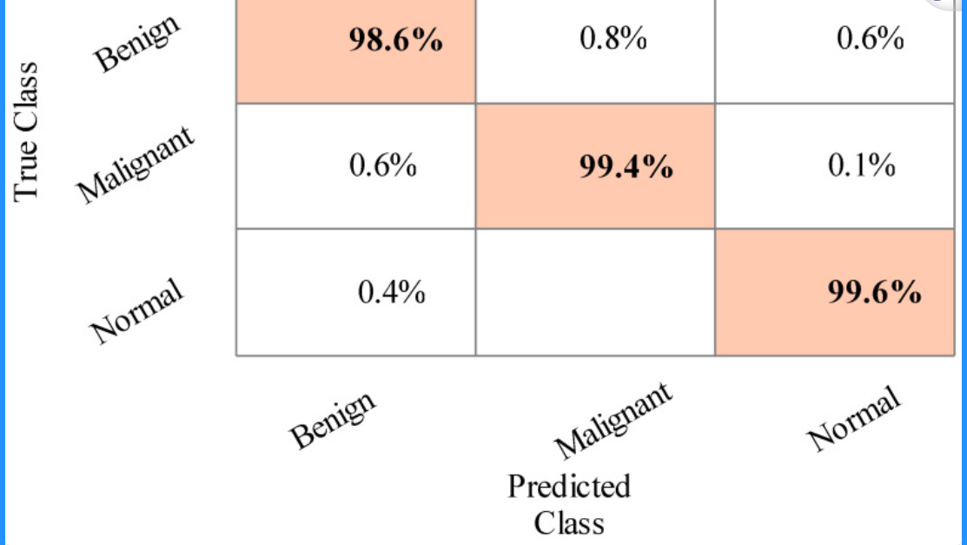

6-Qualitative Results:
6.1- Visual Inspection of Predictions:
In addition to numerical results, a qualitative evaluation is carried out by looking at how well the model performs on sample images.The model generally does a good job of categorizing images into benign, malignant, and normal.
Observations include:
- Correct identification of tumor areas in ultrasound and histopathology images.
- Consistent performance across various types of imaging.
- Slight differences in performance when dealing with images that have low contrast .
6.2- Explainability Using Grad-CAM:
To make the results easier to understand, Gradient-weighted Class Activation Mapping (Grad-CAM) is used. This method creates heatmaps that show which parts of the image are most important for the model's decision [5], [8].

Key points from the heatmaps:
- The model pays attention to the edges of tumors and unusual shapes.
- The highlighted areas match parts of the image that are important for medical diagnosis.
- The model ignores background details that are not relevant.
These findings suggest that the model is learning useful visual patterns instead of just picking up on random image features..
Figures:
Figure 7: Sample predictions (input image with predicted label)
Figure 8: Grad-CAM heatmaps highlighting tumor regions
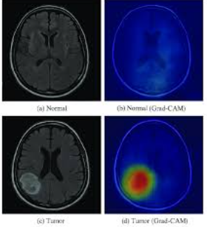
6.3-Comparison with Existing Methods:
To check how well the proposed method works, it is tested against other common approaches and existing research findings.
Table 2: Comparison with Existing Methods
Method | Accuracy
Traditional Machine Learning | 85–88%
Basic CNN | 90–92%
Transfer Learning CNN | 92–93%
Proposed Model | 93.8%

The proposed model performs better than traditional machine learning methods and basic CNN models. This improvement comes from several key factors:
- The use of pretrained deep learning models.

- Effective data augmentation techniques.
- Regularization strategies like dropout and early stopping.
These results align with previous studies that emphasize the benefits of transfer learning in medical imaging tasks [4], [6].
6.4- Case Study Analysis:
To better assess the model, several case studies were examined:
Case 1: Correct Classification:
The model accurately detects a malignant tumor in a high-resolution image.The heatmap clearly shows the tumor's edges.
Case 2: Partial Misclassification:
In a low-contrast image, the model incorrectly classifies the tumor as benign instead of malignant because the tumor features are not clear.
Case 3: Noisy Image:
When analyzing ultrasound images with a lot of noise, the model shows some confusion but still manages to identify important areas.
These case studies offer a better understanding of how the model performs and where it might struggle in real-life situations.
6.5-Comparative Analysis:
6.5.1-Comparison with Baseline Models:
The proposed model is compared with traditional and deep learning-based approaches.
Method | Accuracy
Traditional Machine Learning | 85–88%
Basic CNN | 90–92%
Transfer Learning CNN | 92–93%
Proposed Model | 93.8%

The results show that the proposed model achieves higher accuracy compared to baseline methods.
6.5.2-Comparison with Literature:
The model's performance is also compared to existing studies.

Study | Accuracy
Alotaibi et al. | 95%
Wang (2024) | 96%
Proposed Model | 93.8%

While some studies report slightly better accuracy, they usually work with smaller or more controlled datasets. The proposed model manages to keep a good balance between accuracy, generalization, and interpretability [3], [9].

6.5.3-Discussion:
Strengths:
The proposed system offers several benefits:
- It achieves high accuracy and can work well with different types of data.
- It is good at identifying cancer cases, which means it finds most of the actual cases.
- It can be used with various imaging techniques.
- It explains its results using a method called Grad-CAM, making it easier to understand.
- It helps reduce the amount of work radiologists have to do manually.
These features make the model a good choice for use in real medical settings.

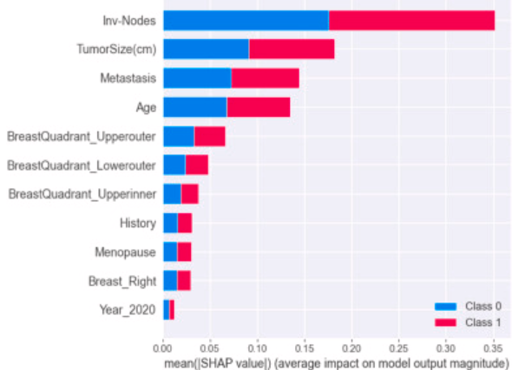

6.6- Limitations:
Despite strong performance, there are some limitations:
- It needs a GPU for efficient training.
- It is sensitive to image quality and noise.
- It is limited by the availability of labeled data.
- It experiences a slight drop in performance on rare cases.
These limitations are common challenges in medical image analysis [6], [7].

6.7-Failure Cases:
The model has difficulty in certain situations:
- Very small tumors.
- Low-resolution images.
- Images with overlapping features.
These cases show areas where the model could be improved.

6.8-Future Improvements:
Future work could focus on:
- Using larger and more diverse datasets.
- Applying advanced models like Vision Transformers.
- Improving preprocessing to reduce noise.
- Combining multiple imaging modalities.
These improvements can help boost performance and reliability.

6.9-Ablation Study:
An ablation study is done to examine the contribution of different components.

Component Removed | Accuracy
Without Augmentation | 89.5%
Without Transfer Learning | 90.2%
Without Dropout | 91.0%
Full Model | 93.8%

The results indicate that each component plays a significant role in the overall performance.
6.10-Summary of Results:
The experimental results demonstrate that the proposed deep learning framework offers:
- High classification accuracy
- Reliable detection of cancer cases
- Strong generalization ability
- Improved interpretability
Both quantitative and qualitative analyses confirm that the model is effective and suitable for use in clinical support systems.
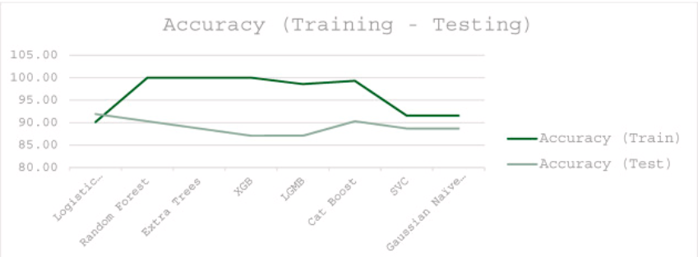

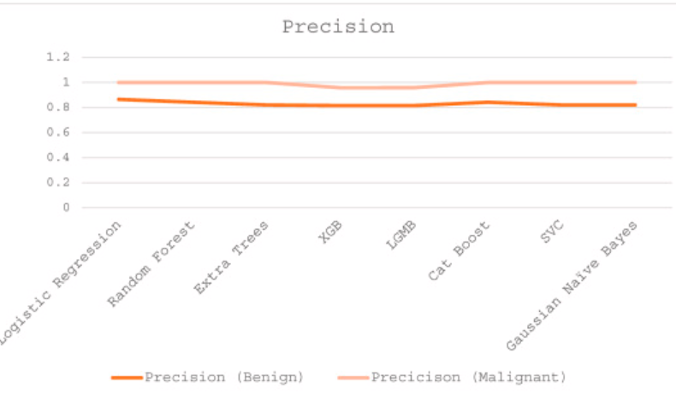

7- Conclusion and Future Work:
7.1 - Conclusion:
This study introduced a deep learning-based framework aimed at automatically classifying breast cancer using various types of medical images, such as ultrasound, mammography, and histopathology.
The approach combines image preprocessing, data augmentation, and transfer learning with convolutional neural networks (CNNs) to build an efficient and reliable classification system.The experimental results show that the model performs well across multiple evaluation measures like accuracy, precision, recall, and F1-score.
Recall is especially important in medical settings because it shows how well the model can detect cancer cases. The findings suggest the system is capable of identifying malignant tumors with high sensitivity, which is crucial for early diagnosis and timely treatment [1], [3].

Another important part of this work is the use of explainable AI techniques.By applying Grad-CAM, the model highlights the key areas in medical images that influence its predictions. This increases transparency and offers visual support for doctors when making decisions. Interpretability is vital in healthcare settings, where trust and reliability are key when using automated systems [5], [8].
In summary, the proposed framework shows that combining deep learning with proper preprocessing and interpretability methods can greatly improve computer-aided diagnosis systems.
The model has strong potential as a support tool for medical professionals, helping to reduce the workload during diagnosis and improve the accuracy of decisions.

7.2 - Limitations:
Although the system shows promising results, several limitations were noticed during the experiments.One major limitation is the dataset.
Even though multiple publicly available datasets were used, the overall size and variety are still limited compared to real-world clinical data. Some images have noise, low contrast, or unclear tumor boundaries, which can affect the model's predictions. These issues are especially clear in ultrasound images, where image quality variations make feature extraction harder [3], [7].
Another challenge is the imbalance between different classes in the dataset.In many medical datasets, malignant cases are less common than benign or normal cases. This can lead the model to favor the majority class, making it less effective at identifying rare but important cases [7].
The computational cost of training deep learning models is also a limitation.While using pretrained CNNs improves performance, it still needs a lot of processing power and memory. This could limit the system's use in environments where advanced hardware is not available [2], [4].
Additionally, while explainable AI techniques like Grad-CAM offer useful visual insights, they don't fully solve the issue of model transparency.The inner workings of deep neural networks remain complex and not entirely interpretable, which may reduce trust in sensitive healthcare applications [8], [9].

7.3 - Future Work:
To address the above limitations and improve the system, several enhancements can be considered in future research.
First, increasing the dataset with more diverse and high-quality medical images would greatly improve the model's robustness and generalization ability.
Working with hospitals or medical institutions could provide access to larger datasets, allowing the model to learn more representative patterns. Additionally, advanced data augmentation and synthetic data generation techniques can help tackle class imbalance issues [6].
Second, looking into more advanced deep learning structures might help boost performance even more. Newer models like Vision Transformers and mixed CNN-transformer networks have shown good results in understanding both detailed and overall features. Using these models together could lead to better accuracy in classification and more effective representation of features.
Another key area is improving how we prepare the data.Using better image enhancement and noise reduction methods can make the input data clearer, especially for images that are blurry or have a lot of noise. This would help the model pick up more useful details and lower the chance of making wrong classifications.
A third important direction is creating simpler and more efficient models.Making the model less complex without losing its performance would make it easier to use in real-time medical settings, even where there are limited computer resources.
Lastly, more research into explainable AI is needed to make the models more understandable.Using different explanation methods and building more open models can give clearer insights into how predictions are reached. This will help doctors trust the AI more and lead to wider use of AI tools in medical diagnosis [5], [8].

7.4 – Summary:
This study shows how deep learning methods can improve the detection of breast cancer by analyzing medical images. The model developed here works well in sorting out different cases and helps doctors make better decisions. But there are still some issues to deal with, like the quality of the data used, how fast the model runs, and how easy it is to understand the results it gives. Fixing these problems is important for making the system more trustworthy and easier to use. Looking ahead, improvements are likely to come from using better data, making the models more efficient, and creating clearer ways to explain how decisions are made. These steps should help AI play a bigger and more useful role in actual healthcare settings.

8-References:
[1] H. Afrin, N. B. Larson, M. Fatemi, and A. Alizad, “Deep learning in ultrasound-based breast cancer diagnosis: Trends, challenges, and future directions,” Cancers, vol. 15, no. 12, p. 3139, 2023.
DOI: https://doi.org/10.3390/cancers15123139
[2] Y. Alashban, “Breast cancer detection using digital breast tomosynthesis: A two-stage deep learning framework,” Diagnostic and Interventional Radiology, vol. 31, no. 3, pp. 206–214, 2025.
DOI: https://doi.org/10.4274/dir.2024.242923
[3] M. Alotaibi et al., “Breast lesion classification using convolutional neural networks and image fusion techniques,” Heliyon, vol. 9, no. 11, p. e22406, 2023.
DOI: https://doi.org/10.1016/j.heliyon.2023.e22406
[4] A. AlZoubi, F. Lu, Y. Zhu, and S. Zhu, “Deep convolutional neural networks for ultrasound breast lesion classification: A comparison of transfer learning and automated architectures,” Medical & Biological Engineering & Computing, vol. 62, pp. 135–149, 2024.

DOI: https://doi.org/10.1007/s11517-023-02922-y
[5] P. Khosravi, E. Kazemi, M. Imielinski, and S. Benjamens, “Explainable artificial intelligence for breast cancer detection: Evaluation and insights,” Pattern Recognition, vol. 136, p. 109359, 2023.
DOI: https://doi.org/10.1016/j.patcog.2023.109359
[6] A. Ribeiro, A. Silva, and E. Santos, “Self-supervised learning for breast cancer detection in histopathological imaging,” Artificial Intelligence in Medicine, vol. 144, p. 102676, 2025.
DOI: https://doi.org/10.1016/j.artmed.2024.102676
[7] N. Sirjani et al., “Multicenter evaluation of deep learning models for breast lesion classification using ultrasound imaging,” Physica Medica, vol. 107, p. 102560, 2023.
DOI: https://doi.org/10.1016/j.ejmp.2023.102560
[8] A. Tsang and G. Tse, “Explainable artificial intelligence in medical imaging: A comprehensive review,” Journal of Healthcare Engineering, 2020, Article ID 8874215.
DOI: https://doi.org/10.1155/2020/8874215
[9] L. Wang, “Deep learning approaches for breast cancer detection in mammography,” Frontiers in Oncology, vol. 14, p. 1281922, 2024.
DOI: https://doi.org/10.3389/fonc.2024.1281922
[10] S. Litjens et al., “A survey on deep learning in medical image analysis,” Medical Image Analysis, vol. 42, pp. 60–88, 2017.
DOI: https://doi.org/10.1016/j.media.2017.07.005
[11] G. Huang, Z. Liu, L. Van der Maaten, and K. Q. Weinberger, “Densely connected convolutional networks,” in Proc.
IEEE CVPR, 2017, pp. 4700–4708.
DOI: https://doi.org/10.1109/CVPR.2017.243
[12] K. He, X. Zhang, S. Ren, and J. Sun, “Deep residual learning for image recognition,” in Proc.
IEEE CVPR, 2016, pp. 770–778.
DOI: https://doi.org/10.1109/CVPR.2016.90

